

Dolphin GuideConnect Quick Reference Guide
Get started with GuideConnect, on a keyboard, touchscreen or Dolphin remote control.

YourDolphin.com
01905 754577

Dolphin Remote Control
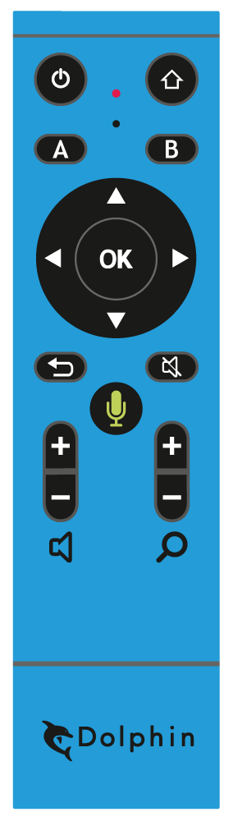
- Exit Menu.
Button located at the top left of the Dolphin Remote Control.
- Actions.
Button located as the second button down on the left-hand side of the Dolphin Remote Control.
- Previous.
Left Previous button located on the left part of the large central circle on the Dolphin Remote Control.
Up Previous button. Located on the top part of the large central circle on the Dolphin Remote Control.
- Select.
Button located in the centre of the large central circle on the Dolphin Remote Control.
- Back.
Button located on the left-hand side underneath the large central circle of the Dolphin Remote Control.
- Volume.
Located as the lowest button on the left-hand side of the Dolphin Remote control. The top part increases volume and the lower part decreases volume.
- Main Menu.
Button located at the top right of the Dolphin Remote Control.
- Help and Information.
Button located as the second button down on the right-hand side of the Dolphin Remote Control.
- Next.
Right Next button located on the right part of the large central circle on the Dolphin Remote Control.
Down Next button located on the bottom part of the large central circle on the Dolphin Remote Control.
- Stop / Start Reading.
Located on the right-hand side underneath the large central circle of the Dolphin Remote Control.
- Voice Input button.
Button located in the centre underneath the large central circle of the Dolphin Remote Control. Press and hold to use.
- Magnification.
Button located as the lowest button on the right-hand side of the Dolphin Remote control. The top part increases magnification and the lower part decreases magnification.

Don’t forget to plug the small USB receiver into a USB port on your computer. You will find it in the battery compartment of the remote control.

Popular Keyboard Shortcuts
CTRL + 0 - Voice On / Off
F1 - Help
F2 - Actions Menu
F3 - Help and information
F4 - Repeat
F5 - Continue reading
F6 - Start voice input
F7 / F8 - Voice volume: Up / Down
F9 / F10 - Voice speed: Up / Down
F11 / F12 - Magnification: Up / Down

Keyboard Shortcuts
Shortcut keys for menus
Next item | DOWN / RIGHT ARROW
Previous item | UP / LEFT ARROW
Select item | ENTER
Back to previous screen | ESCAPE
Help | F1
Actions | F2
Help & Information | F3
Read current item | F4
Start Voice Input | F6
Interrupt speech | CTRL

Shortcut keys for reading
Next / previous line | DOWN / UP ARROW
Continuous read | F5
Pause | CTRL
Switch voice | SHIFT + F11

Shortcut keys for writing
Next / previous | CTRL + RIGHT / LEFT ARROW
Selecting text | SHIFT + ARROWS
Copy selected text | CTRL + C
Paste text | CTRL + V
Next / previous character | RIGHT / LEFT ARROW

Shortcut keys for websites
Next / previous item | DOWN / UP ARROW
Next / previous character | RIGHT / LEFT ARROW
Next / previous word | CTRL + RIGHT / LEFT ARROW
Turn images ON / OFF | CTRL + I
Change display mode | CTRL + T
Next heading | H
Next edit area | E
Next link | K
Back a page | BACKSPACE

Touchscreen
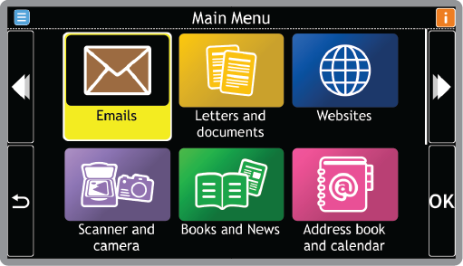
- Actions (appears when available).
Icon located at the top left-hand corner of the touch display.
- Help & Information.
Icon located at the top right-hand corner of the touch display.
- Previous.
Icon located to the left-hand edge of the touch display in the top half.
- Go Back.
Icon located to the left-hand edge of the touch display in the bottom half.
- Select.
Icon located to the right-hand edge of the touch display in the bottom half.
- Next.
Icon located to the right-hand edge of the touch display in the top half.

Help and Support

Get Started with GuideConnect
If you’re new to GuideConnect, we recommend you watch the ‘Getting Started’ training videos. In just a few minutes, you’ll learn how to control GuideConnect on your chosen device.
Go to Tools > Training > Training Videos > Getting Started

GuideConnect Training
Choose your preferred training options.
Choose from:
- Training videos - watch and learn
- Training podcasts - listen and learn
- Shortcut keys list - keyboard commands
- Typing tutor - improve your typing skills
You can find these tutorials in GuideConnect.
Go to Tools > Training
In the UK, GuideConnect customers can take advantage of 2 hours free telephone training and UK based technical support. If you’re outside the UK, ask your Dolphin dealer about the support they offer.

In-product Help
To get Help and Information when you’re using GuideConnect:
- Select the ‘i’ button in the top right of the GuideConnect screen
- Press the F1 button on your keyboard
- Click the B button on your Dolphin remote control

YourDolphin.com/GuideConnect

